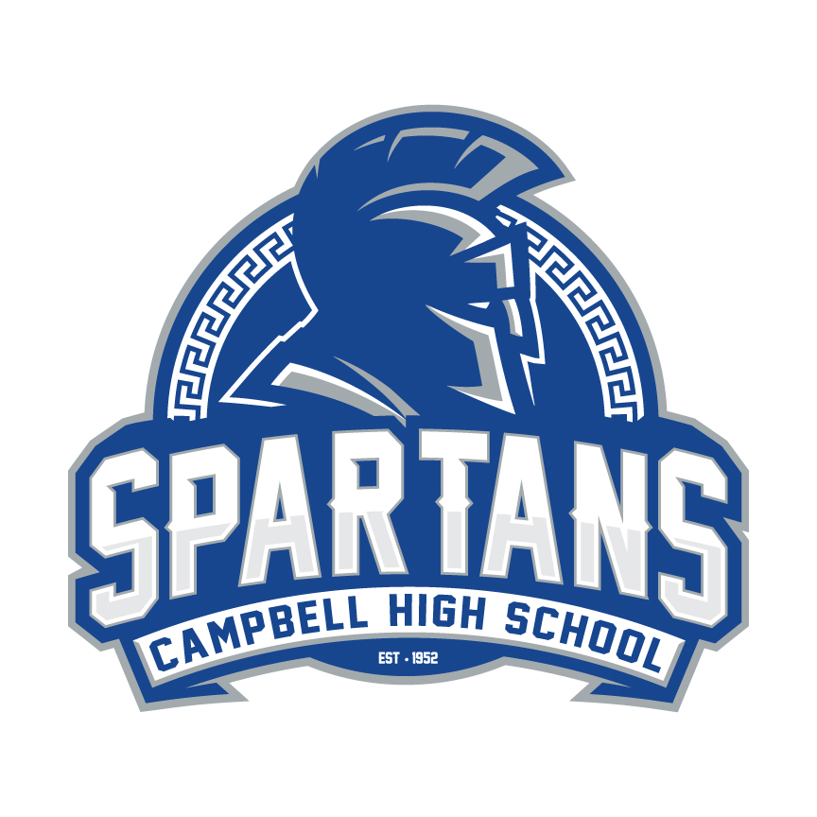
Campbell High School
5265 Ward Street Smyrna, GA 30080
School Website: http://www.cobbk12.org/CampbellHS/ Phone: 678-842-6850

Course Syllabus
World History
Spring 2019

Instructor: Timothy Rose
Email: timothy.rose@cobbk12.org
Blog: https://mrrosecampbellhs1.weebly.com/

- Course Description: This class will examine major themes and events around the world from the earliest civilizations up to modern history. The primary resource for this class will be our textbook: World History: Patterns of Interaction. The curriculum is centered around the Georgia Performance Standards and the Common Core for World History, which can found on the Cobb County website under the Picasso tab. This class will use standard based grading, which will be outlined in more detail below.

- Units of Study
Unit 1 - Rise of Civilizations
Unit 2 – Emergence of Classical Empires
Unit 3 – Great Empires of the World
Unit 4 – The Birth of New Ideas
Unit 5 – Age of discovery and Expansion
Unit 6 – Age of Reason and Revolutions
Unit 7 – The Global World Collides
Unit 8 – Globalization & the Modern Era

- Texts and Resources: World History Textbook from HMH Social Studies

- Methodology and Class Expectations: The high school world history course provides students with a comprehensive, intensive study of major events and themes in world history. Students begin with a study of the earliest civilizations worldwide and continue to examine major developments and themes in all regions of the world. The course culminates in a study of change and continuity and globalization at the beginning of the 21st century. Students are expected to come to class prepared and ready to learn.
- Methods of Assessment and Evaluation: The following will be used routinely in order to assess and evaluate student performance: Formative assessments, summative assessments, projects, Document Based Questions (DBQ’s), daily work, group work, and note taking. Rubrics will be used for all major projects.

- Grading: Standards based grading system. Each unit will be worth a percentage of your grade. The percentages are listed below. There is also a mid-term and final exam included in your grade. At the end of every unit any grade of a 0 that has not been made up will remain a 0.

Unit 1 - Rise of Civilizations 10%
Unit 2 – Emergence of Classical Empires 10%
Unit 3 – Great Empires of the World 10%
Unit 4 – The Birth of New Ideas 10%
Unit 5 – Age of discovery and Expansion 10%
Unit 6 – Age of Reason and Revolutions 10%
Unit 7 – The Global World Collides 10%
Unit 8 – Globalization & the Modern Era 10%
Midterm- 10%
Final Exam – 10%

- Homework: There will be homework assigned in this class. Students will be required to finish homework on the day it was assigned and turned in when returning the next day. If the student is absent on the due date, the homework is expected to be turned in on the day they return to class. If the student is absent on the day homework is assigned the student is expected to collect any missing work the day they return and turn it in the following day. Students are expected to study and review materials covered in class daily.

- Classwork: Students will have daily work throughout the semester, both work that will be due by the end of the class as well as work that will be completed in their notebook. Classwork is due at the end of the class and may not be accepted the following day. Work done in the notebook will be stamped to show completion/accuracy on the due date and later collected at the end of each unit for a grade.

- Projects: there will be projects, both group and individual, throughout the semester. When assigned the students will be given a due date and it is the class expectation that the project is completed and turned in for credit.

- Make-Up Policy: Students may turn in work for partial credit two weeks after the due date for the assignment. After the two weeks students will not be able to make up the assignment and receive a 0.

- Tutoring: Tutoring schedule will be posted by department. Each teacher will have a scheduled tutoring time. However, teacher needs to be notified ahead of time.

- Restroom and Hall Passes: Restroom and hall passes will be limited and at the teachers discretion. Students who abuse bathroom privileges will be stripped of them. Students that require frequent trips to the restroom for medical reasons must bring a doctor’s note. DEAD TIME will be observed the first and last 15 minutes of every class period.

Movie Permission Form:
I, __________________________________________________________________________________________________________________- (printed parent name)

___________________________________________________________________________________________________________________- (printed student name)

Having read and understood the contents of the syllabus, do agree to abide by the rules set forth within. I also do accept that my child may be exposed to films/television programming that may have a rating of PG-13 and DO OR DO NOT (please circle one) give consent to allow my child to participate in the viewing of these items. Children will be given an alternative assignment if needed (this is not a punishment).

I DO or DO NOT (please circle one) give consent for the viewing of PG-13 Films.

Parent Signature _______________________________________________________________________________________ Date ______________________

Student Signature ______________________________________________________________________________________ Date _____________________

RETURN THIS FORM WITH BOTH SIGNATURES BY Friday January 25, 2019.

