World History Final Study Guide: Part 1 Key

- How did the ancient Mesopotamians increase food production.
Digging irrigation canals
- Describe the Bantu Migration, and its significance.
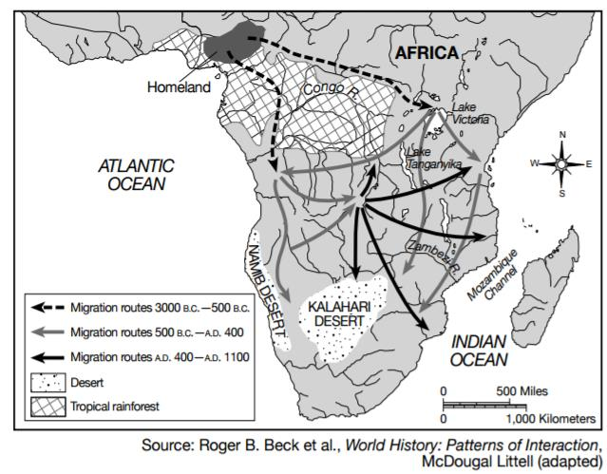
- Which civilization was King Solomon from?
Hebrew
- What are the 5 characteristics of an advanced civilization?
specialized skills, record keeping, improved technology, advanced cities, and complex institutions
- What is the belief in many gods?
polytheism
- Why did Egyptians make mummies?
to preserve their pharaohs for the afterlife
- What civilizations used Cuneiform and Hieroglyphics?
Mesopotamians (cuneiform) and Egyptians (hieroglyphics)
- What is a Patriarchal social organization?
a social organization were the male is at the head of the family
- Which religion believes in Karma, Dharma, Reincarnation, and the Caste System?
Hinduism
- Who was Siddhartha Gautama, and why is he significant?
founder of the religion Buddhism
- What trade route connected China and the West?
Silk Road
- What Greek word means "city state"?
Polis
- What type of government was Athens credited with?
democracy
- What are believers of Hinduism are expected to do?
obey their caste for a favorable reincarnation
- Which geographic feature was central in helping the Romans unify their empire?
the Mediterranean Sea
- What was one of the lasting contributions of Alexander the Great?
Hellinism, the cultural blending of Greek, Egyptian, Persian, and Indian cultures as a result of Alexander's conquests
- What was and how long did the Pax Romana last?
relative peace throughout Rome for over 200 years
- How were the kingdoms of Ghana, Mali, and Songhai all able to grow strong?
Control over the Trans Sahara trade routes
- Who created the Hagia Sophia and made Constantinople a major center of trade and religion?
Emperor Justinian
- What group took over the Byzantine Empire?
The Ottoman Turks
- The strategic location of the Byzantine Empire allowed control of the key trade routes between what 2 seas?
the Black Sea and the Mediterranean Sea
- Who founded Islam?
Muhammad
- Disagreements over communion, celibacy, and excommunication eventually led to what?
The Great Schism
- An influence that spread from the Byzantine Empire to Early Russia was what?
Orthodox Christianity
- Who united the Mongol clans around 1200 CE/AD?
Genghis Khan
- Which two major commodities were traded by West African kingdoms?
Gold and Salt
- Most of which continent came under Mongol influence and rule?
Asia
- What was a primary goal of European Crusades fighting in the Middle East?
to control Christian holy sites in Jerusalem
- What effect did the Black Death have on the feudal system?
the feudal system was never able to fully recover due to labor shortages all over Europe
- Which situation was a result of the Protestant Reformation?
More Christian denominations
- Why where the Crusades & Black Plague considered a turning point in history?
they led Europe from the Middle Ages into the Renaissance
- The Reformation got under way when Matin Luther wrote what?
the 95 Theses
- What is the historical significance of Charlemagne?
He was the first Holy Roman Emperor
- Who invented the printing press?
Johann Gutenberg

